Kubernetes Que
Kubernetes Assignment -1
Tasks to be Performed:

1. Deploy a kubernetes cluster for 3 nodes
=> 1. minikube start –nodes=3 –driver=docker –p my-three-node-cluster : to create the three node cluster using minikube
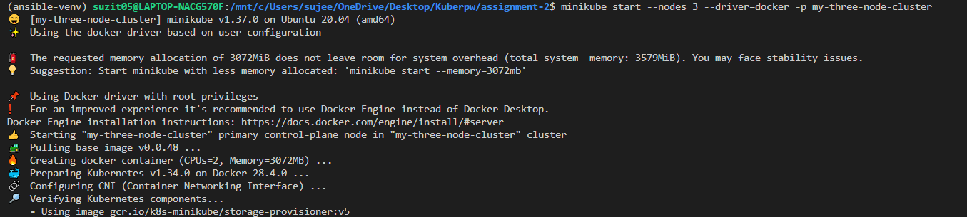

2. minikube status –p my-three-node-cluster : to verify the status of the cluster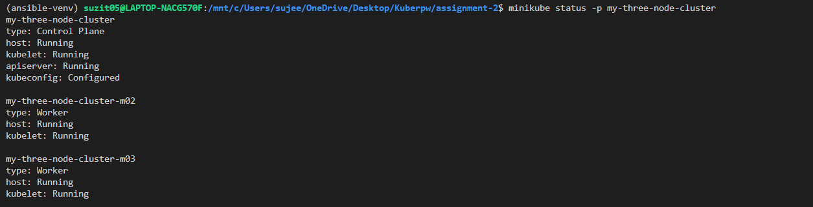

2. Create a NGINX deployment of 3 replicas.
=> 1. Create the yml file for for nginx deployment.

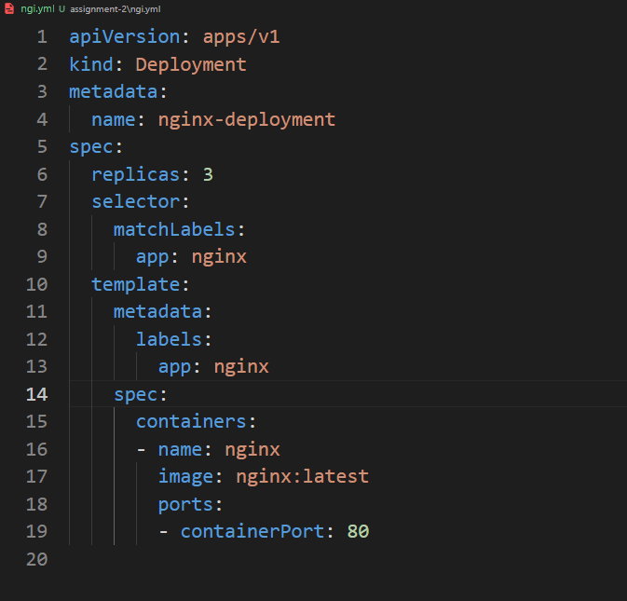
2. kubectl apply –f ngi.yml : apply the deployment
3. kubectl get pods : verify pods
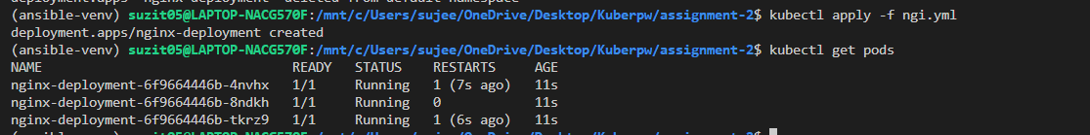

Kubernetes Assignment -2
1.Using the previous deployment
2.Create a Service of type NodePort for NGINX deployment
3.Check the NodePort service on the browser to verify
=>
1. nginx-nodeport-svc.yml:
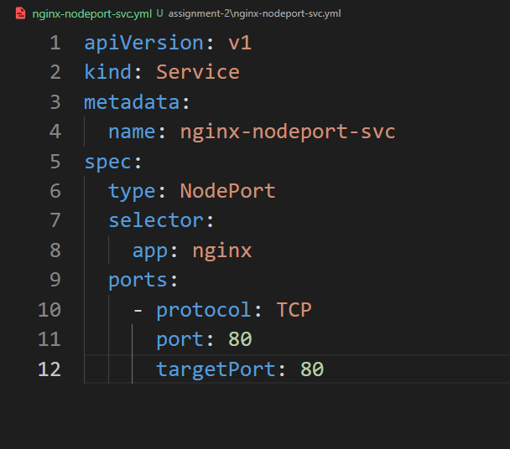

2. kubectl apply -f nginx-nodeport-svc.yml : apply to create the service
3. kubectl get svc: to verify the service
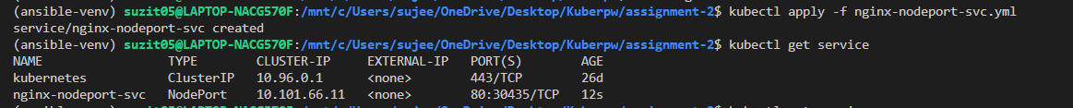

4. minikube service nginx-nodeport-svc: to access the service outside the cluster via url
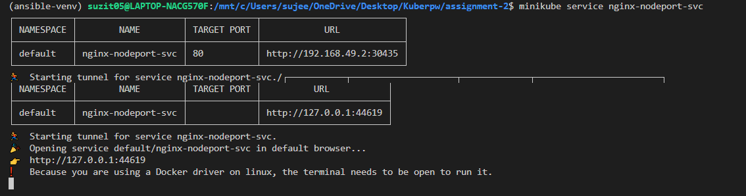

5. Now, Visit the Url


Kubernetes Assignment- 3
1.Use the previous deployment
2.Change the replicas to 5 for the deployment
=>
1. Either we can edit the yml file or using the command to change the replicas
2. kubectl scale deployment nginx-deployment --replicas=5 : to scale replicas to 5
3. kubectl get deployments : to verify the scaling

Kubernetes Assignment -4
1. Use the previous deployment
2.Change the service type to clusterIP
=>
1. Edit the nginx-nodeport-svc.yml file , from type:NodePort to type:ClusterIP
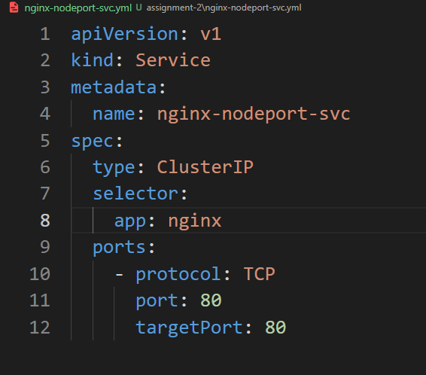
2. kubectl apply –f nginx-nodeport-svc.yml : to save the file after editing
3. kubect get svc: to list the service to verfiy the work

Kubernetes Assignment-5
1. Use the previous deployment
2. deploy a nginx deployment of 3 replicas (assignment-1)
3. create a nginx service of type cluster IP (assignment-4)
4. Create an ingress service/Apache to apace service/ Nginx to nginx service
=>
1. nginx-ingress.yml
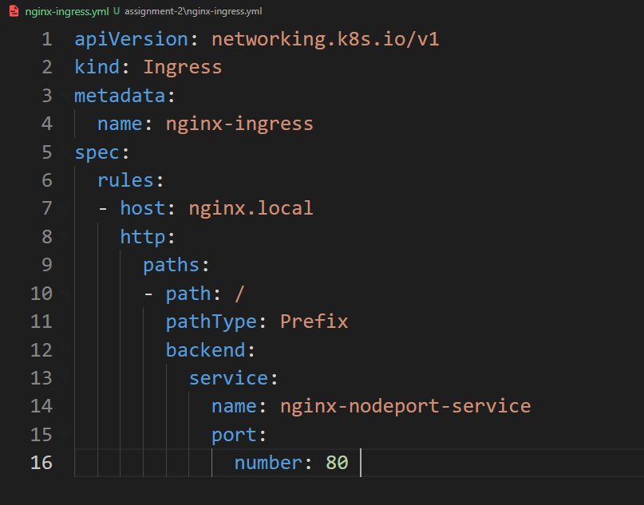
2. Make sure minikube ingress is add on: minikube addons enable ingress

3. kubectl apply –f nginx-ingress.yml : to create the ingress

4. kubectl get ingress : to verify the ingress status

5. Test url in browser: http://nginx.local/apache

